If you want to set up storage spaces, right-click the Start button and choose Control
Panel. In the upper-right corner, change the View By option from Category to Large Icons.
Scroll down to Storage Spaces and double-click Storage Spaces (see Figure 3.33).
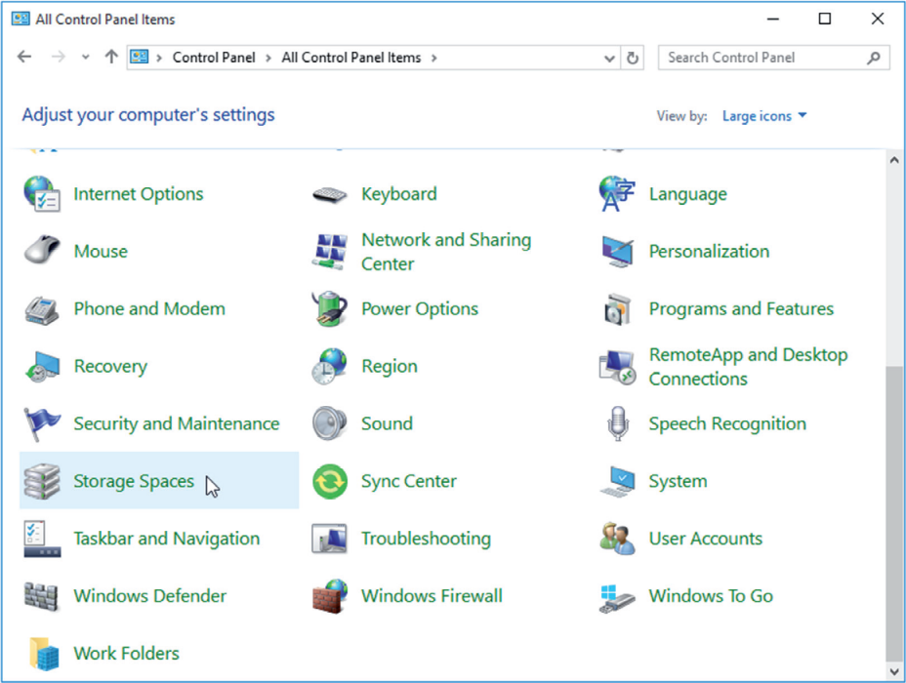
After you double-click and open Storage Spaces, you would complete the following steps
to create a storage pool:
- Click the “Create a new pool and storage space” link (shown in Figure 3.34).
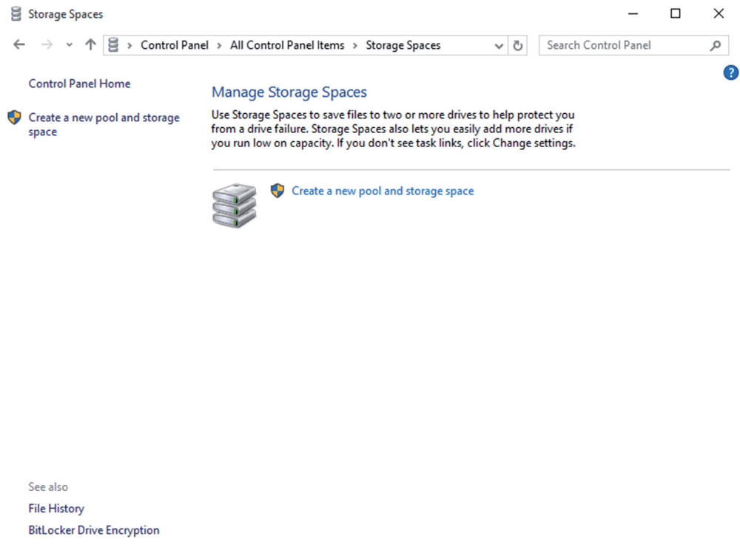

2. Select the drives you want to add to the new storage space, and then click or click
Create Pool.
3. Give the drive a name and letter, and then choose a layout (Simple, Two-Way Mirror,
Three-Way Mirror, or Parity).
4. Enter the maximum size the storage space can reach, and then click Create Storage Space.
Now that you have seen how you can protect your data, in the next section, we will look
at how you can keep your disk volumes and partitions running at peak performance.

